|  |
| --- |
| CCPA Business Requirements  Margin Calculation (BRS-MA)  Version 0.1 ● Proposed |
|  |
| |  |  | | --- | --- | |  |  | |

Table of Contents

1. Overview 3

2. Calculation of Initial Margin – Cross Margining Model 4

2.1 Mark-to-Market Calculation 5

2.2 Additional Margin Calculation 6

2.3 Cross Initial Margin Amount 7

3. Calculation of Initial Margin – Cross Margining Model 8

3.1 Mark-to-Market Calculation 9

3.2 Additional Margin Calculation 10

3.3 Initial Margin Amount 11

# Overview

The document describes the methodology used to calculate Initial Margin amount in case of Cross Margining Model and No Cross Margining Model.

The methodology adopted foresees the following types of Initial Margins:

1. **Mark-To-Market Margin**: it has the purpose of revaluating the theoretical liquidation gains/losses to current market prices (Mark-To-Market). It represents a theoretical credit for the clearing member that has bought/sold shares below/above current market prices, assumed equal to the reference price. On the other side, it represents a theoretical debit for the clearing member that has bought (sold) shares above (below) current market prices.
2. **Additional Margin**: it has the purpose of evaluating the maximum loss reasonably possible in the hypothesis of market price fluctuations of the securities. Additional Margin is the incremental cost of liquidating a portfolio in the event of a worst case change in the price of the securities

# Calculation of Initial Margin – Cross Margining Model

If Multicurrency/Multimarket Cross Margining is performed in a Clearing Account the:

* Positions corresponding to financial instruments having same ISIN and Currency and different Market are netted in a single position, producing a single margin requirement
* Positions corresponding to financial instruments having same ISIN and different Currency are kept separated but the respective price/currency scenarios are offsetted to produce a single Margin Requirement.

The scenario worst case in such case is calculated over the following factors:

* price variation: represented by the financial instrument risk factor;
* currency variation: represented by the currency haircut (for the "Cash Call Currency" the haircut factor is always 0)

The calculation specification is described below:

Figure 1

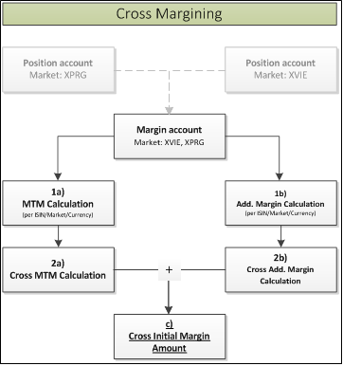

## Mark-to-Market Calculation

**1a) The CCP carries out the calculation for each ISIN separately per Position Account:**

* If Position = Long

*Mark-to-Market (Trade currency) = Net Quantity[1] * (Last Price – Settl. Price)*

* If Position = Short

*Mark-to-Market (Trade currency) = Net Quantity[2] * (Last Price – Settl. Price)*

If the *Trade Currency ≠ Clearing Currency* the *Exchange Rate* and *Haircut on Exchange Rate* is applied. The *Haircut on Exchange Rate* is applied considering the sign of Mark-to-Market:

* If the Mark-to-Market is a debit amount:

$Mark-to-Market \left(clearing currency\right)=\frac{Mark-to-Market \left(trading currency\right)}{Exchange Rate}$*(1+ *Haircut on Exchange Rate)*

* If the Mark-to-Market is a credit amount:

$Mark-to-Market \left(clearing currency\right)=\frac{Mark-to-Market \left(trading currency\right)}{Exchange Rate}$*(1- *Haircut on Exchange Rate)*

**2a) Cross Mark-to-Market Calculation per Margin Account ID:**

Once the Mark-to-Market has been calculated in the Clearing Currency for each Position Account ID, the CCP sums the amounts obtained for the same ISIN traded in the different Market (Position Account).

*Cross Mark-to-Market = Mark-to-Market (Position Account 1) + Mark-to-Market(Position Account2)*

## Additional Margin Calculation

**1b) Calculation for each ISIN, separately per Position Account ID, of the Downside and Upside theoretical price.**

$$Downside Scenario=Last Price*(1-Margin Interval)$$

$$Upside Scenario=Last Price*(1+Margin Interval)$$

**Calculation for each ISIN, separately per Position Account ID, of the “Downside Gain/Loss” and the “Upside Gain/Loss”:**

* Downside Gain Loss:
$$Downside Gain Loss=Quantity*(Max Downside Scenario- Last Price)$$

* Upside Gain Loss:

$$Upside Gain Loss=Quantity*(Max Upside Scenario- Last Price)$$

**Calculation of Downside and Upside Gain Loss in Clearing currency**

If the *Trade Currency ≠ Clearing Currency* the *Exchange Rate* and *Haircut on Exchange Rate* is applied. The *Haircut on Exchange Rate* is applied considering the signs of *Upside/Downside Gain Loss* calculated in the previous step:

* If *Downside/Upside Gain* Loss is a debit amount*:*
$$Downside Gain Loss \left(Clearing Currency\right)=\frac{Max Downside Gain Loss \left(Trading Currency\right)}{Exchange Rate}*(1+Haircut on Exchange Rate)$$

* If *Downside/Upside Gain* Loss is a credit amount*:*

$$Downside Gain Loss \left(Clearing Currency\right)=\frac{Max Downside Gain Loss \left(Trading Currency\right)}{Exchange Rate}*(1-Haircut on Exchange Rate)$$

**2b) Calculation of cross Downside and Upside Gain Loss at Margin Account ID Level**

The CCP sums the “*Downside Gain Loss”* and the “*Upside Gain Loss”* obtained in different Position ID:

$$Cross Downside Gain Loss \left(Clearing Currency\right)= Downside Gain Loss \left(Pos. Acc. 1\right)+Downside Gain Loss (Pos.Acc.2)$$

$$Cross Upside Gain Loss \left(Clearing Currency\right)= Upside Gain Loss \left(Pos. Acc. 1\right)+Upside Gain Loss (Pos.Acc.2)$$

**Calculation of Cross Additional Margin at Margin Account ID:**

$Cross Additional Margin=min⁡(Cross Downside Gain Loss (Clear. Curr); Cross Upside Gain Loss(Clear. Curr.)$)

## Cross Initial Margin Amount

**C)** Cross Initial Margins is equal to the sum of Cross Mark to Market calculated in the previous step 2a and Cross Additional Margin calculated in the previous step 2b

*Initial Margin=Cross Mark to Market + Cross Additional Margin*

# Calculation of Initial Margin – Cross Margining Model

If Multicurrency/Multimarket Cross Margining is not performed in a Clearing Account the:

* Positions corresponding to financial instruments having same ISIN and Currency and different Market are not netted in a single position and produce multiple margin requirement;
* Positions corresponding to financial instruments having same ISIN and different Currency are kept separated and the respective price/currency scenarios are not offsetted. In this way multiple Margin Requirement are produced.

The calculation specification is described below:

Figure 2

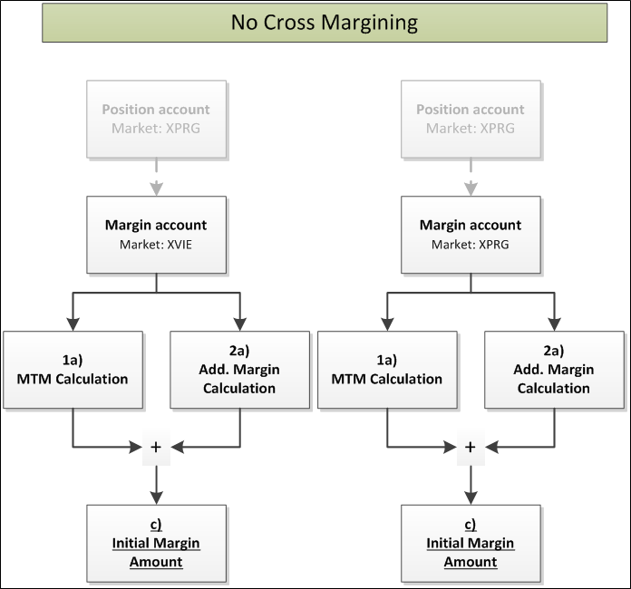

## Mark-to-Market Calculation

**1a) The CCP carries out the calculation for each ISIN separately per Position Account:**

* If Position = Long

*Mark-to-Market (Trade currency) = Net Quantity[3] * (Last Price – Settl. Price)*

* If Position = Short

*Mark-to-Market (Trade currency) = Net Quantity[4] * (Last Price – Settl. Price)*

If the *Trade Currency ≠ Clearing Currency* the *Exchange Rate* and *Haircut on Exchange Rate* is applied. The *Haircut on Exchange Rate* is applied considering the sign of Mark-to-Market:

* If the Mark-to-Market is a debit amount:

$Mark-to-Market \left(clearing currency\right)=\frac{Mark-to-Market \left(trading currency\right)}{Exchange Rate}$*(1+ *Haircut on Exchange Rate)*

* If the Mark-to-Market is a credit amount:

$Mark-to-Market \left(clearing currency\right)=\frac{Mark-to-Market \left(trading currency\right)}{Exchange Rate}$*(1- *Haircut on Exchange Rate)*

## Additional Margin Calculation

**1b) Calculation for each ISIN, separately per Position Account ID, of the Downside and Upside theoretical price.**

$$Downside Scenario=Last Price*(1-Margin Interval)$$

$$Upside Scenario=Last Price*(1+Margin Interval)$$

**Calculation for each ISIN, separately per Position Account ID, of the “downside Gain/Loss”** **and the “upside Gain/Loss”:**

* Downside Gain Loss:
$$Downside Gain Loss=Net Quantity*(Downside Scenario- Last Price)$$

* Upside Gain Loss:

$$Upside Gain Loss=Quantity*(Upside Scenario- Last Price)$$

**Calculation of Downside and Upside Gain Loss in Clearing currency**

If the *Trade Currency ≠ Clearing Currency* the *Exchange Rate* and *Haircut on Exchange Rate* is applied. The *Haircut on Exchange Rate* is applied considering the signs of *Upside/Downside Gain Loss* calculated in the previous step

* If *Downside/Upside Gain* Loss is a debit amount*:*
$$Downside Gain Loss \left(Clearing Currency\right)=\frac{Downside Gain Loss \left(Trading Currency\right)}{Exchange Rate}*(1+Haircut on Exchange Rate)$$

* If *Downside/Upside Gain* Loss is a credit amount*:*

$$Downside Gain Loss \left(Clearing Currency\right)=\frac{Downside Gain Loss \left(Trading Currency\right)}{Exchange Rate}*(1-Haircut on Exchange Rate)$$

**Additional Margin Calculation**

$Additional Margin=min⁡(Downside Gain Loss (Clear. Curr); Upside Gain Loss(Clear. Curr.)$)

## Initial Margin Amount

**C)** Initial Margins is equal to the sum of Mark to Market calculated in the previous step 1a and Additional Margin calculated in the previous step 1b

*Initial Margin= Mark to Market + Additional Margin*

1. If the position is Short the “net quantity” is a negative number
2. If the position is Short the “net quantity” is a negative number
3. If the position is Short the “net quantity” is a negative number
4. If the position is Short the “net quantity” is a negative number